**Building a website: Create your first website using-MIX/Canva**

BRAND NAME: MODERN ARCHITECTURE

CATEGORY: REAL ESTATE AND MARKETING

TARGET AUDIENCE: ALL

EMAIL:modernarchitecture123@gmail.com

CANVA WEBSITE URL: <https://modern-architecture.my.canva.site/>

SCREENSHOTS:

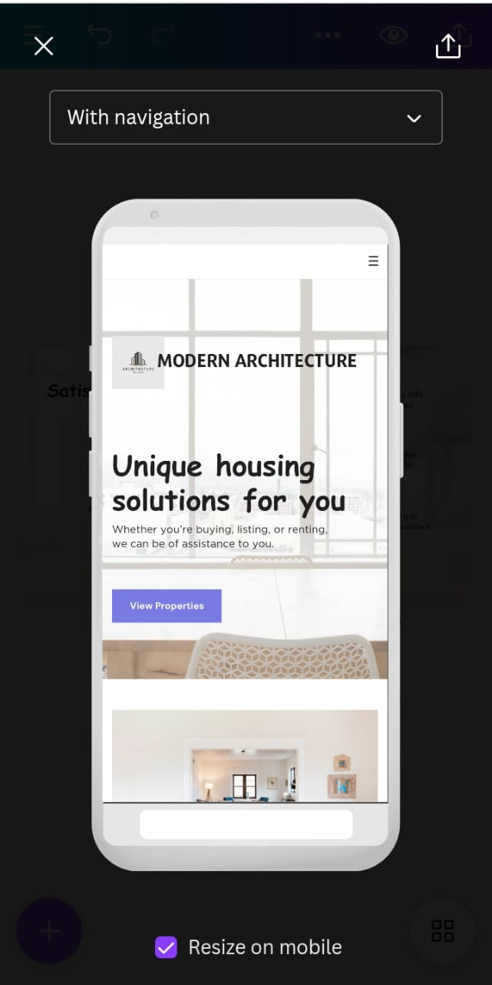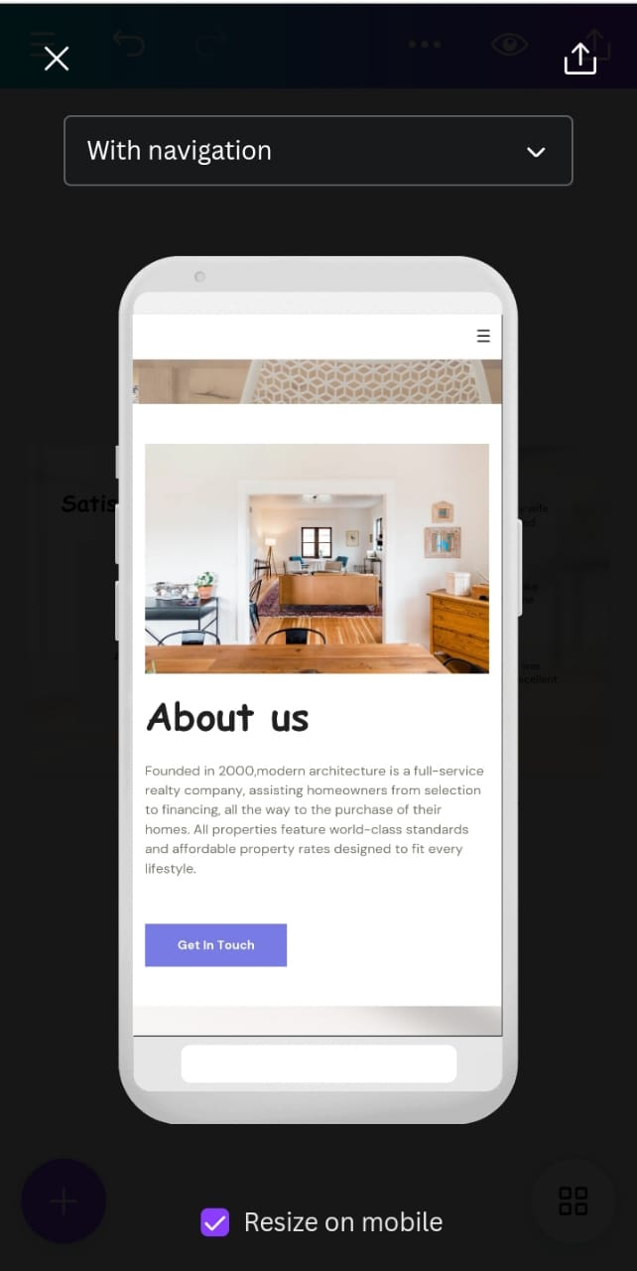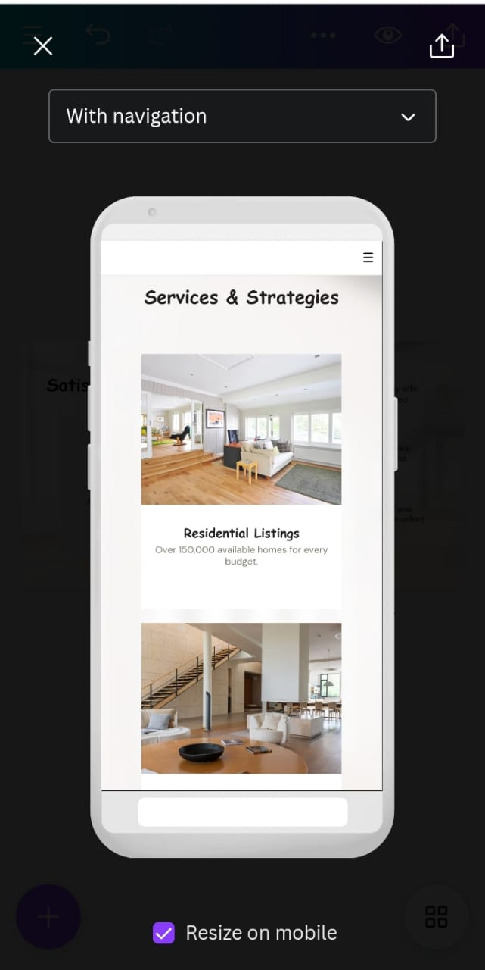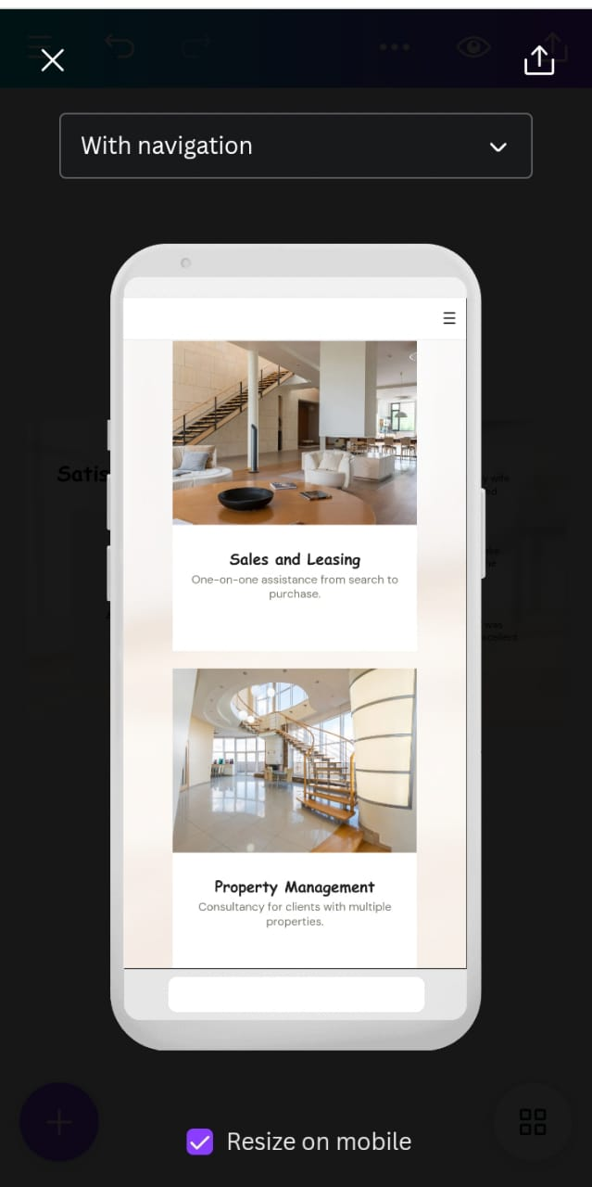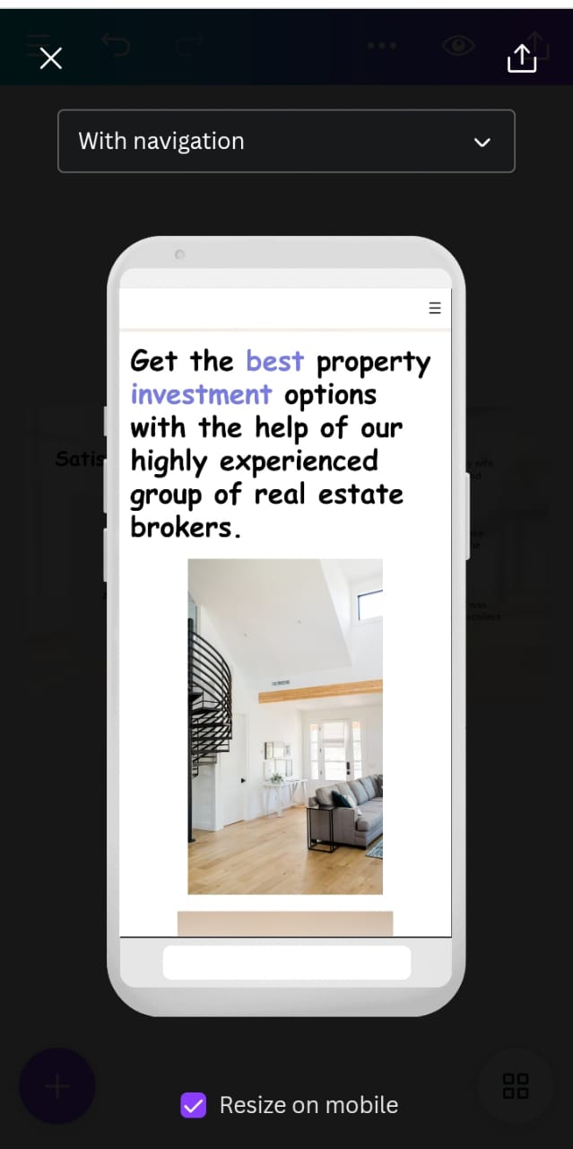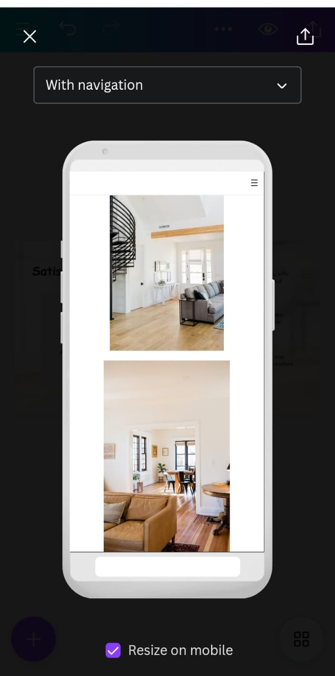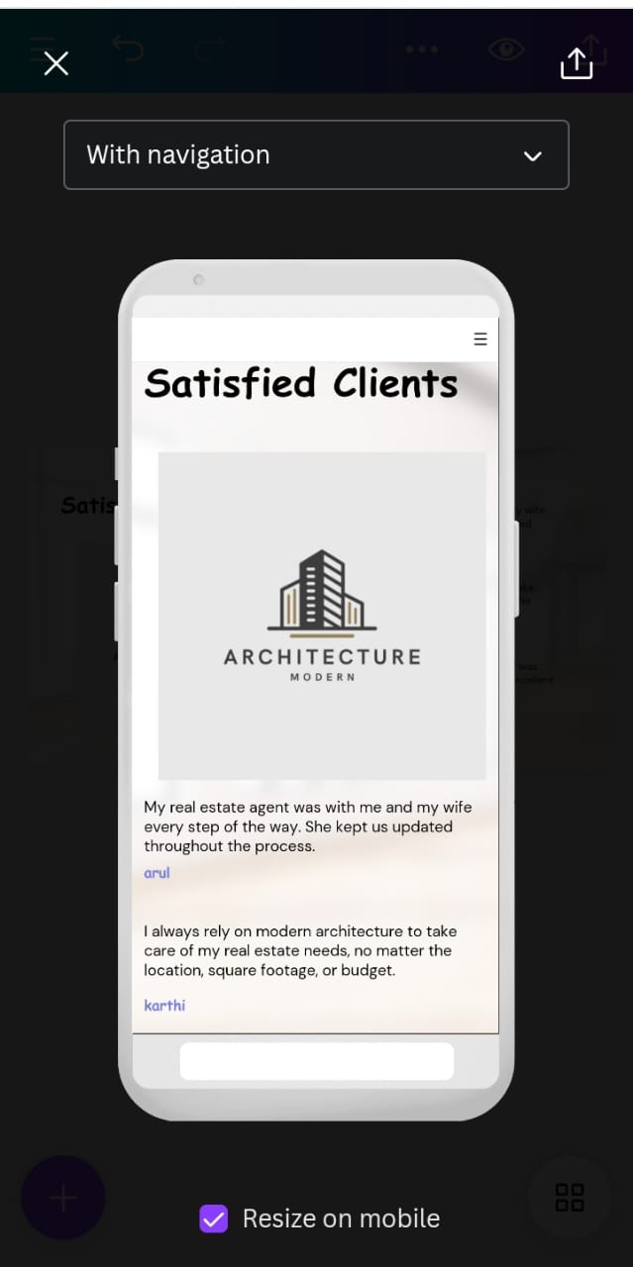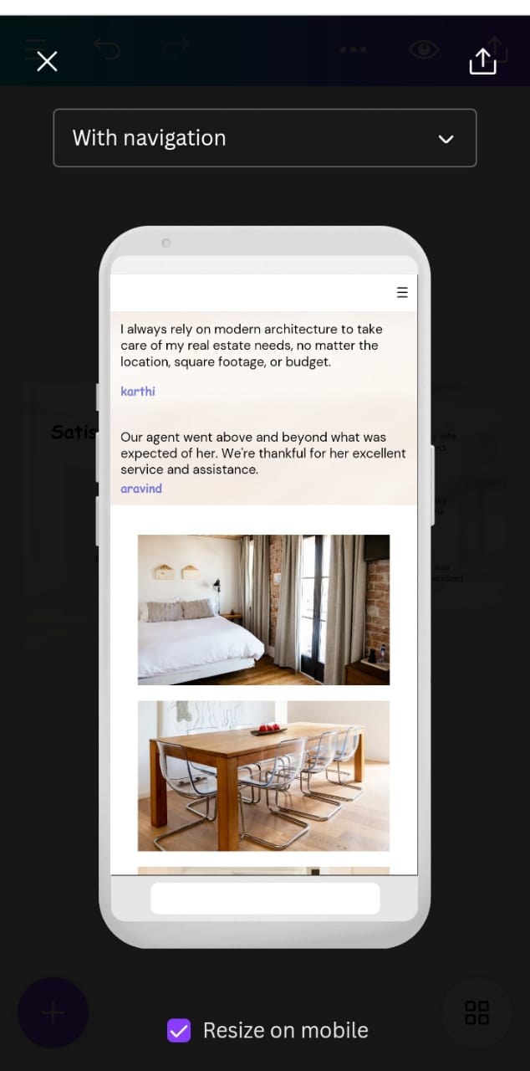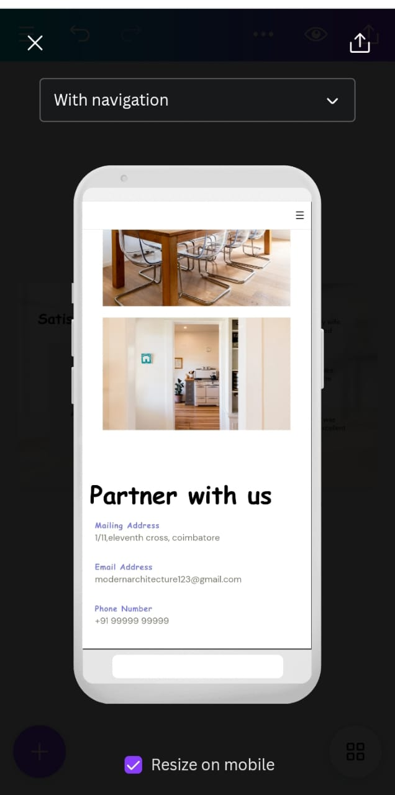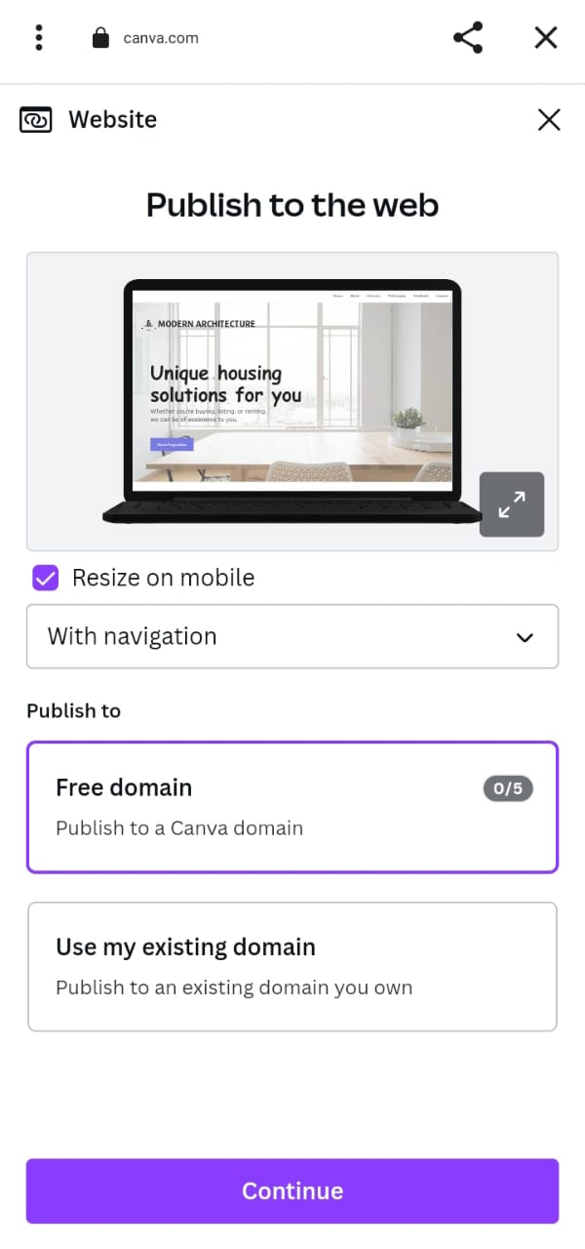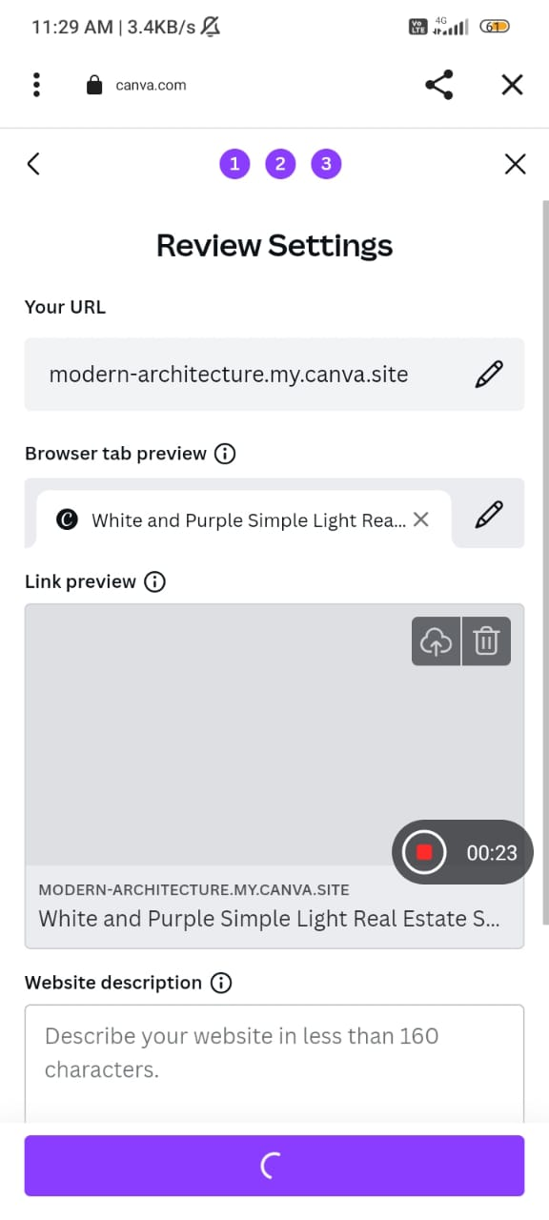

VIDEO LINK: <https://photos.app.goo.gl/z3STTcXqjmDZc1wD9>

MAIL CREATION AND SCREENSHOTS:

